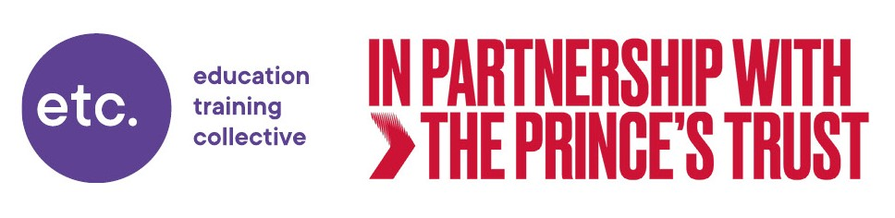

12 Week Prince’s Trust

TEAM Programme

- The Prince’s Trust Team is a 12-week course for young people aged 16 – 25years.
- The course is available to young people from all areas of the local community and all abilities.
- Young people can claim existing benefits whilst on the programme due to a national agreement between DWP and the Prince’s Trust.
- The course focuses on progression, employability and helping young people achieve their potential and it ensures all young people have every opportunity to gain formal recognition of their skills and achievements.
- The young people gain qualifications that offer flexibility, choice, and pathways to progression.
- The qualification is available at levels Entry 3, L1 and L2.

Team programme outline:

Week 1: Induction Week
A fast-paced week designed to promote team building, introduce Health & Safety, community awareness and transferable core skills, including communication, problem solving, tolerance and working with others. Initial BKSB assessments are undertaken, and action plans set with the young people.

Week 2: Team Building
The teambuilding week promotes team building and problem-solving skills, often in an outdoor education setting, and encourages the group to bond and learn to work together. The aim is to improve self-confidence and provide the opportunity to take responsibility as a leader in activities and challenges.

Weeks 3 - 6: Community Project
During this module the Team will find, plan and undertake a project in their local area. This is a practical project (decorating, renovation, etc), and it may include skills training where possible and encourages them to build links with their community and other agencies.

Weeks 7 and 8: Work Related Experience
Young people will gain valuable experiences through work related opportunities and employability skill development. During these weeks we will link up with employers to experience different work places and undertake essential skill development to equip the young people for the work place.

Week 9: Next Steps
Next Steps Week is an opportunity to work on life skills and consider what options there might be after the completion of the course. Time is spent carrying out job searches, mock interviews and creating personal CVs. Careers guidance and employment options focused on with support from NCS and local colleges.

Weeks 10 and 11: Final Team Challenge
This is the Team’s chance to take on a challenge involving supporting other people in the community. The planning and execution is carried out by the young people and utilises many of the skills and experiences that they have acquired in the past weeks.

Week 12: Presentation and Review
The final week of the Programme culminates in a presentation to an invited audience to promote what the young people have achieved over the past twelve weeks. This week also provides an opportunity to review all the learning that has taken place and to complete the Individual Learning Records which go forward to be assessed for the Certificate in Employment, Teamwork and Community Skills. The Presentation is an opportunity to award the Certificates achieved by young people in front of an invited audience.

Qualification
On completion of the Team programme and a portfolio of evidence from your 12 weeks you will achieve a nationally recognised qualification:

Prince’s Trust Certificate (E3, L1 or L2) in Employment, Teamwork and Community Skills
GLH: 252hrs
Funded at 420 hrs (due to Prince’s Trust Funding guide exemption)

Courses run three times per year in each delivery location:
- Stockton Riverside College
- Middlesbrough (Breckon Hill Community Centre)
- Darlington
- Bishop Auckland, (Four Clocks Centre)
- Catterick (Risedale Youth Centre)

Start dates are September / January / May

For more information, please contact Gillian Hutchinson ,
Head of Department, Prince’s Trust gillian.hutchinson@the-etc.ac.uk
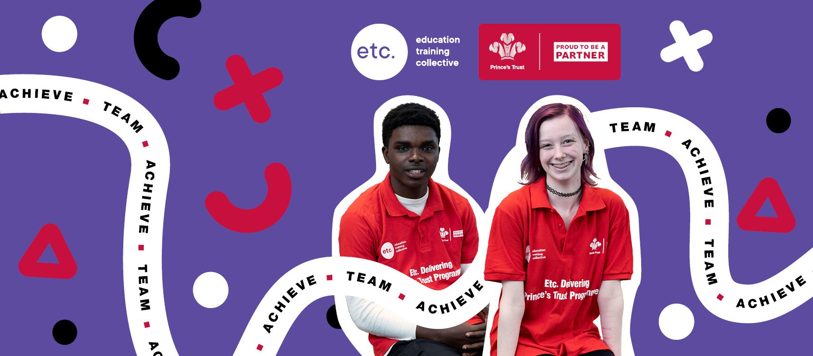
Mobile: 07969428101

