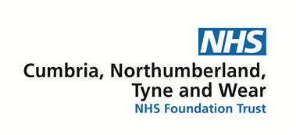

Becoming an NHS Foundation Trust Governor

Our Trust and being a Member
Our History - Cumbria, Northumberland, Tyne and Wear has been an NHS Foundation Trust since December 2009. As a Foundation Trust if we didn’t have members like yourself, we wouldn’t have a Trust, so it is important to keep our membership well represented by the public, service users and carers, our workforce and partners across the North East, North Cumbria and beyond.

What is a Foundation Trust? - NHS Foundation Trusts were originally created back in 2003 as part of the Health and Social Care Act 2003. We are free from central government control which gives us the freedom to make our own decisions for the Trust. However, we are still subject to statutory requirements, and we all have a duty to show and prove we are working effectively, efficiently, and economically.

What is a Member? – A NHS Foundation Trust Member has an opportunity to help shape your local NHS in many ways. As a member you can do as little or as much as you like, including receive regular membership newsletters about what we have going on, complete questionnaires to voice your views, get to attend membership events and meet the staff and Directors. You can also vote for governors in elections or stand as a governor yourself.

Our membership is made up of the following constituencies:
- Service Users - Our Service User Members are people who have used our services within the last six years.

- Carers - Our Carer Members are people who look after someone who has used our services within the last six years.

- Public - Our Public Members can live anywhere in England and Wales.

- Staff - Anyone employed by CNTW or NTW Solutions.
Anyone can become a member as long as you are aged 14 and above.

Our Council of Governors
What is the role of NHS Foundation Trust Council of Governor? –

Overall responsibility for running an NHS Foundation Trust lies with the Board of Directors, and the Council of Governors is the collective body through which Directors explains and justify their actions. Holding to account is therefore not about the performance of individual directors, nor performance management of the Board.

The Council’s role is as follows:

- To consider the Board’s account of its performance against the criteria that the Council has agreed with the Board and based on conditions in the Provider Licence.

- To question the Board on its account and feed back in a considered manner based on the evidence presented (asking for more evidence if necessary and reasonable).

Our Council of Governors are made up of individual Governors who have chosen to be involved in different capacities, for different reasons with different views on the Trust. This mix helps the Trust be truly representative of the community it serves.

- 7 Public Governors

- 7 Carer Governors

- 7 Service User Governors

- 7 Governors from each council that we have services in

- 7 Staff Governors

- 2 Governors from Community and Voluntary Organisations

- 4 Governors from Local Universities

Who can be a Governor? – To nominate yourself to be a Governor you must be a Member of the Trust and be aged 16 and above.

Our Service User Governors need to either:
- Be currently accessing one of the services up for election
- Have used one of the services up for election within the past 6 years

Our Carer Governors need to either:
- Be currently caring for someone who is accessing one of the services up for election
- Have cared for someone who has used one of the services up for election within the past 6 years

Our Public Governors have to currently reside in the area that they wish to nominate themselves for.

Our Staff Governors need to currently be employed by Cumbria, Northumberland, Tyne and Wear NHS Foundation Trust or by NTW Solutions within the correct category (Clinical, Non-Clinical and Medical) and represent the views of staff. If you are unsure which one your job role falls under, please email us on members@cntw.nhs.uk

You cannot stand for election to be a Governor at CNTW if you are a Governor, Executive or Non-Executive Director of another NHS Trust/Foundation Trust

What is expected from someone on the Council of Governors? – NHS Foundation Trust Governors are the direct representatives of local interest within their organisation. Governors do not undertake operational management of the Trust, rather they challenge the Board of Directors and hold NEDS to account for the Board’s performance. It is also the Governors’ responsibility to represent their members’ interests, particularly in relation to the strategic direction of the Trust.

The purpose of the Council of Governors is:

- Act in the best interest of the Trust and adhere to its values and Code of Conduct and work closely and collaboratively with the Board in an open and transparent way.

- Governors must represent members of the Trust and the Public.
Engagement with members is a vital part of how Governors fulfil their intermediary role between the Trust and the membership. Foundation Trusts are required to demonstrate that they are engaged with their membership and governors are a vital communication route through which that happens.

- Hold the Non-Executive Directors individually and collectively to account for the performance of the Board of Directors.

- To appoint, remove and decide upon the terms of office (including levels of remuneration) of the Chair and Non-Executive Directors of the Trust

- To appoint or remove the Trust’s external auditor.

- To approve or not approve the appointment of the Trust’s Chief Executive Officer.

- To approve or not approve an application by the Trust to enter into an acquisition, merger, separation and dissolution.

- To approve changes to the Trust Constitution jointly with the Board.

- To receive the annual report and accounts and auditor’s report at a General meeting.

- Significant transactions must be approved by the Governors.

- Governors are required to attend the Council of Governor meetings 4 times per year, this can be in person or online through Microsoft Teams video calling.

The Council of Governors can expect to attend a variety of meetings organised by the Trust, which intend to help inform their decision-making and to support Governors in fulfilling their duties. Formally, this will include Council of Governors meetings and Annual Members Meetings. Governors will also be encouraged to attend Public Trust Board meetings. As well as becoming involved in:
Taking part in Governor and Board Committees - These Committees meet to discuss important things in more detail that the normal Council of Governor Meetings do not allow time for, but everything is then fed back to the full Council of Governors, so no one is ever excluded from any information they need to see.
Governors can visit CNTW services – Along with staff members to help us make sure the environment in which they are working from is good and stable.
Governors choose and vote for a Lead and Deputy Lead Governor for the Council - Our current Lead Governor is Anne Carlile and our current Deputy Lead Governor is Tom Rebair. They work with the Chairman to make sure the Council of Governors works well. The Lead Governor takes up this role for 3 years at a time.

What happens if I am successful in being elected on to the council of Governors? – You will be invited to an Induction with all the other new Governors and sometimes some of the current Governors come along to meet you as well. Here you will meet the Corporate Affairs Team, learn more in depth about the Governor role, receive any resources you need and you will also be asked to sign our Code of Conduct, this is very important as it will help you to understand how you should behave when representing the Trust as a Governor and what you can and cannot do in your role.

How can I become a Governor and how long for? – You can nominate yourself to be a Governor whenever we announce our Elections. If more than one person puts in a nomination for a post, then the members of your constituency vote for who they wish to represent them. If you are the only nomination, you will automatically be elected on to the Council. Once elected you will serve for a term of 3 years, at which point you could stand again if you wish to continue, or you can choose to step down. You can be elected up to 3 times, as long as you are still eligible.

What support will I receive as a Governor? - As a Trust we will make sure that you have all the information, advice and support to do your role well. The Corporate Affairs Office is the first point of contact for our Governors. You can find their details at the end of this guide.

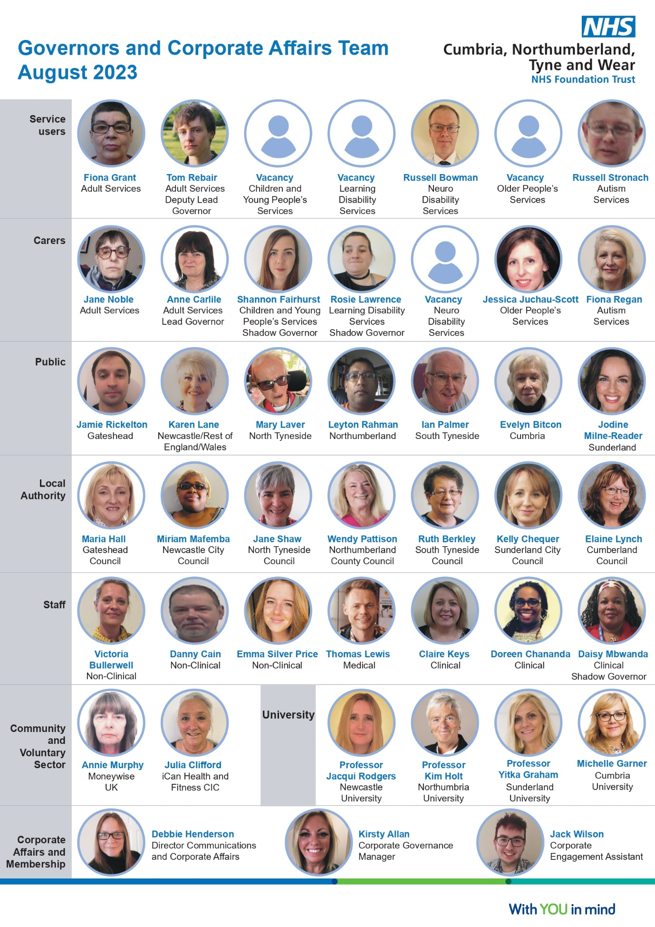

What vacancies does CNTW currently have on its Council of Governors?

This is an exciting opportunity to represent the interests of Foundation Trust members and partner organisations making sure that the views of the wider community are considered in developing our services.

The Trust gives notice that it will hold elections to the Council of Governors in the following constituencies for a 3-year term commencing 1st December 2023.
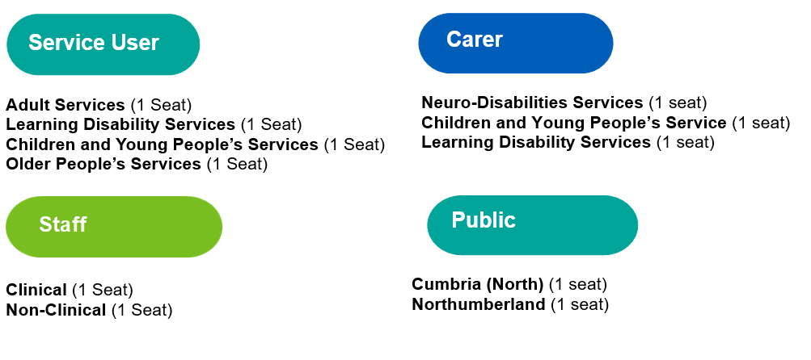

If you would like more information on how to apply to become a Governor, please email: corporateaffairs@cntw.nhs.uk

A nomination form to stand for election to these positions can be obtained from the Returning Officer in the following ways:

- Telephone: 0208 889 9203
- Online: www.cesvotes.com/cntw23
- Email: ftnominationenquiries@cesvotes.com
- Text: Text 2FT NW and your name and address to 88802
- Post: Civica Election Services, The Election Centre, 33 Clarendon Road, London, N8 0NW

Should any nominee wish to withdraw their nomination, they must put this in writing to the Returning Officer by 5pm, Wednesday 25th October 2023.

Deadline for completed nomination is: 5pm on Friday 20th October 2023

If you wish to speak to a member of the team please use the details below.

Debbie Henderson
Director of Communications and Corporate Affairs/Company Secretary

Kirsty Allan
Corporate Governance Manager / Deputy Trust Secretary

Jack Wilson
Corporate Engagement Assistant

You can talk to any of us within the Corporate Affairs Office via:
Phone 0191 2456827 or email corporateaffairs@cntw.nhs.uk
We look forward to you joining us!

